**DAILY ONLINE ACTIVITIES SUMMARY**

|  |  |  |  |  |  |  |  |  |
| --- | --- | --- | --- | --- | --- | --- | --- | --- |
| **Date:** | **20/05/2020** | | | | | **Name:** | **SPOORTI S DAROJI** | |
| **Sem & Sec** | **4th SEM. & ‘B’ SEC.** | | | | | **USN:** | **4AL18CS088** | |
| **Online Test Summary** | | | | | | | | |
| **Subject** | | **OBJECT ORIENTED CONCEPTS** | | | | | | |
| **Max. Marks** | | **30** | | **Score** | | | 19 | |
| **Certification Course Summary** | | | | | | | | |
| **Course** | **Python for Machine Learning** | | | | | | | |
| **Certificate Provider** | | | **Greatlearning**  **academy** | | **Duration** | | | **5 Hrs.** |
| **Coding Challenges** | | | | | | | | |
| **Problem Statement 1:** [**Write a C Program to Reverse a Linked List (SLL) in groups of given size.**](https://github.com/orgs/alvas-education-foundation/teams/2nd-year/discussions/67)  **Problem Statement 2:**  **Write a C or Java program to implement FCFS and SJF process scheduling.**  **Input: Processes with burst time**  **Output: Process being scheduled** | | | | | | | | |
| **Status: executed.** | | | | | | | | |
| **Uploaded the report in Github** | | | | | **Yes** | | | |
| **If yes Repository name** | | | | | **Lockdown Coding** | | | |
| **Uploaded the report in slack** | | | | | **Yes** | | | |

**Online Test Summary: 18CS45 online test was scheduled from 9:30 am t0 10:10 am .The portion for the IA was 1st module, the questions were MCQ type.**

**Online Certification course Summary: Today I’ve gone through Jupyter notebook shortcuts.**

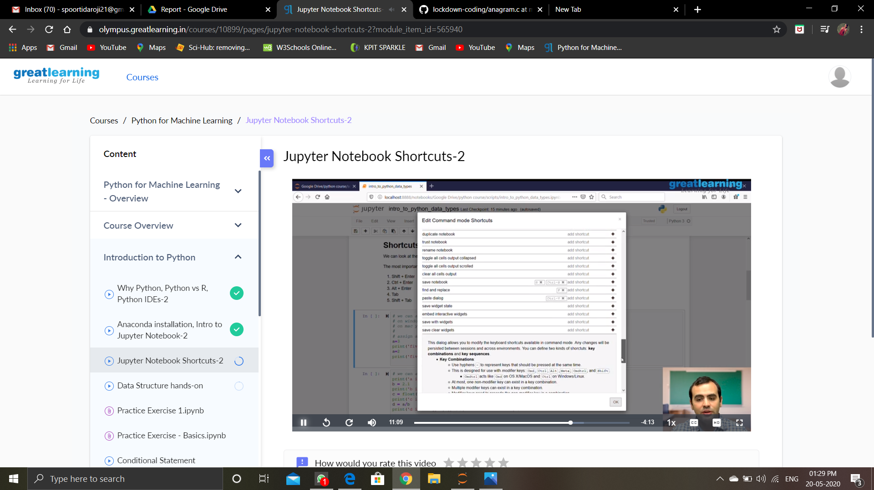**There are main four shortcuts :**

* **Shift + Enter**
* **Ctrl + Enter**
* **Tab**
* **Shift + Tab**

**Shift + Enter -> runs the cell and goes to the next cell.**

**Ctrl + Enter -> runs and stays in the current cell.**

**Tab -> tab-completion is done by dropdown menu.**

**Shift + Tab -> gives the description of the function and tells actually how that function works.**

**It is shown in the below snapshot.**

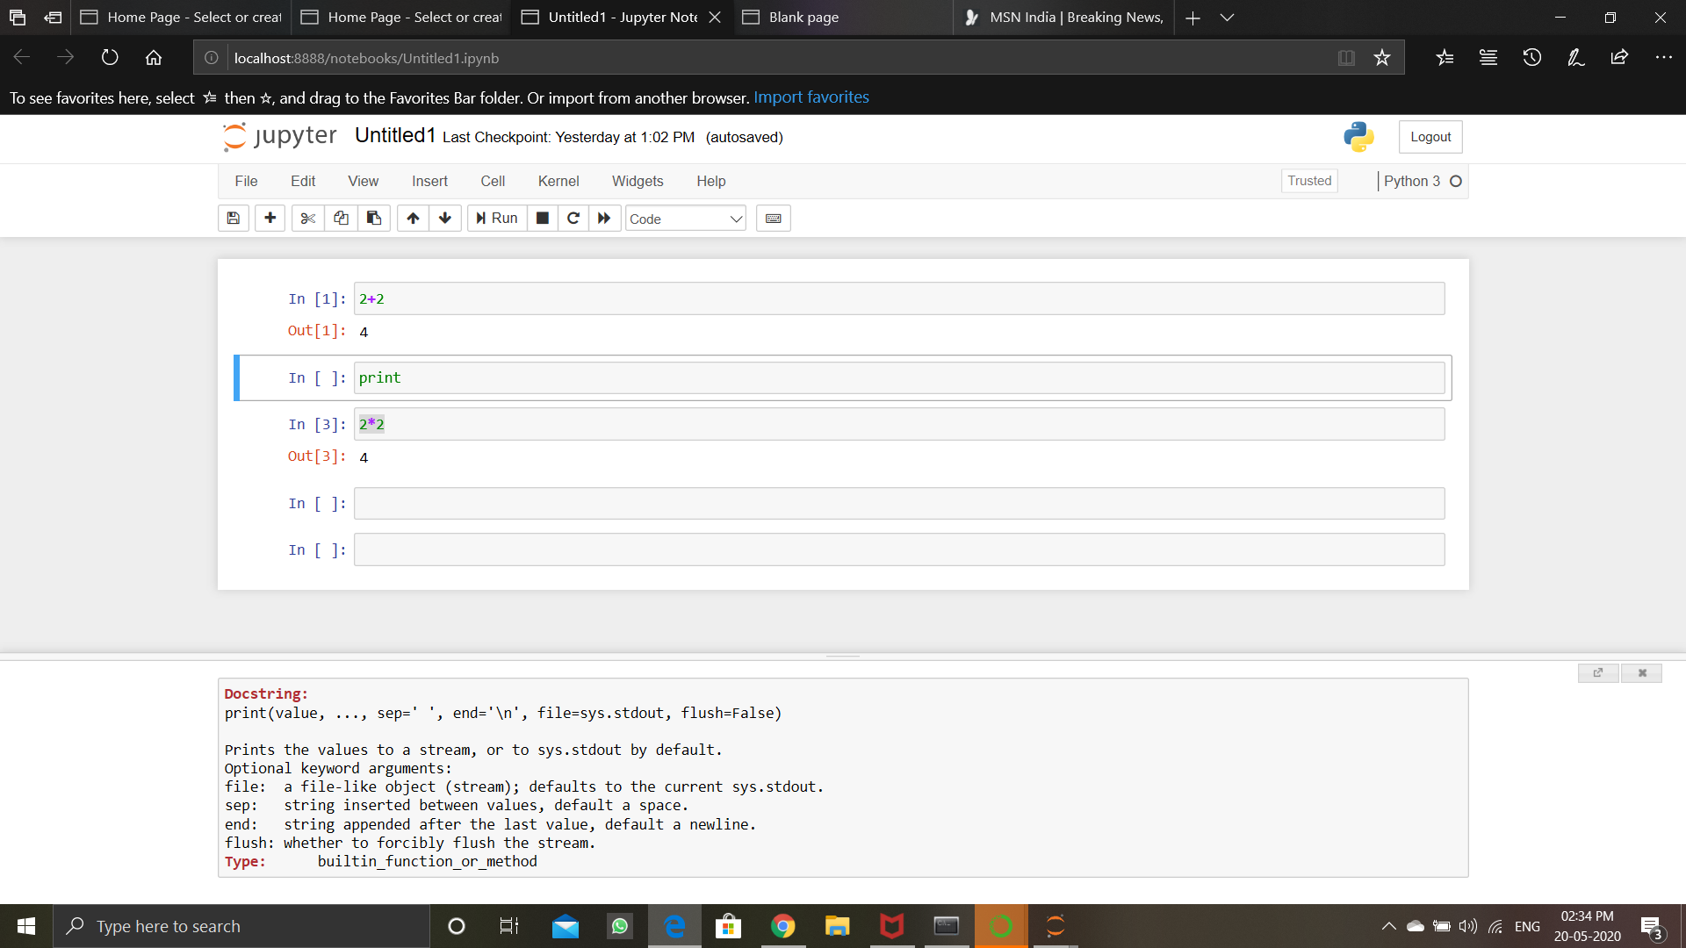

**Online Coding Summary: Today I received the first program from prof.Venkatesh CSE Dept, second program was given by prof.Harshitha GM CSE Dept 1)** [**Write a C Program to Reverse a Linked List (SLL) in groups of given size.**](https://github.com/orgs/alvas-education-foundation/teams/2nd-year/discussions/67) **2) Write a C or Java program to implement FCFS and SJF process scheduling.**

**I have written programs and uploaded it to my Github repository.**

**link as follows:**[**https://github.com/spoortidaroji/lockdown-coding**](https://github.com/spoortidaroji/lockdown-coding)